Units
# Source: AI Source: Provided by: [Data Path: Persons Table -> ID Column: 1, Name_En Column: Motasem Essam] -> From: [ChatGPT] on [7/17/2026]
Units are standardized quantities used to express the magnitude of a physical quantity. They provide a common language for describing measurements so that results are consistent, comparable, and universally understood.
For example:
- A length can be expressed in meters (m).
- A mass can be expressed in kilograms (kg).
- A time interval can be expressed in seconds (s).
Without standardized units, measurements would have no consistent meaning across different people, laboratories, or countries.

Definition
# Source: AI Source: Provided by: [Data Path: Persons Table -> ID Column: 1, Name_En Column: Motasem Essam] -> From: [ChatGPT] on [7/17/2026]
A unit is a standardized quantity adopted by convention to measure and express the magnitude of a physical quantity.

Purpose
# Source: AI Source: Provided by: [Data Path: Persons Table -> ID Column: 1, Name_En Column: Motasem Essam] -> From: [ChatGPT] on [7/17/2026]
units are used to:
- Standardize measurements.
- Ensure consistency worldwide.
- Enable comparison of results.
- Support scientific research.
- Facilitate engineering and manufacturing.
- Improve communication.
- Reduce measurement errors.

Characteristics
# Source: AI Source: Provided by: [Data Path: Persons Table -> ID Column: 1, Name_En Column: Motasem Essam] -> From: [ChatGPT] on [7/17/2026]
Measurement units:
- Represent a fixed standard quantity.
- Are internationally recognized.
- Can be combined to form derived units.
- May use prefixes to represent larger or smaller quantities.
- Are defined by the International System of Units (SI) or other recognized systems.

Types of Measurement Units
Measurement units are generally classified into:

1. SI Base Units
# Source: AI Source: Provided by: [Data Path: Persons Table -> ID Column: 1, Name_En Column: Motasem Essam] -> From: [ChatGPT] on [7/17/2026]
These are the seven fundamental units of the International System of Units.
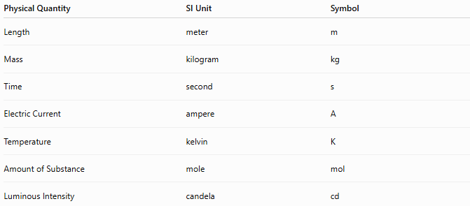
Physical Quantity | SI Unit | Symbol
Length | meter | m
Mass | kilogram | kg
Time | second | s
Electric Current | ampere | A
Temperature | kelvin | K
Amount of Substance | mole | mol
Luminous Intensity | candela | cd

2. SI Derived Units
# Source: AI Source: Provided by: [Data Path: Persons Table -> ID Column: 1, Name_En Column: Motasem Essam] -> From: [ChatGPT] on [7/17/2026]
Derived units are formed by combining SI base units.
Examples:
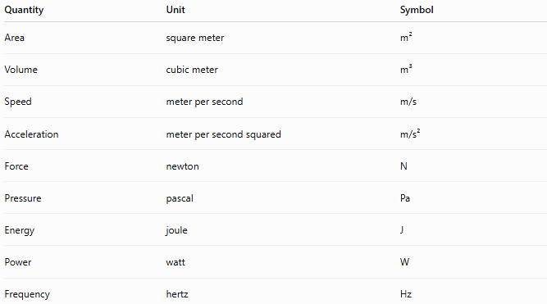
Quantity | Unit | Symbol
Area | square meter | m²
Volume | cubic meter | m³
Speed | meter per second | m/s
Acceleration | meter per second squared | m/s²
Force | newton | N
Pressure | pascal | Pa
Energy | joule | J
Power | watt | W
Frequency | hertz | Hz

3. Non-SI Units Accepted for Use
# Source: AI Source: Provided by: [Data Path: Persons Table -> ID Column: 1, Name_En Column: Motasem Essam] -> From: [ChatGPT] on [7/17/2026]
Some non-SI units are officially accepted alongside SI units.
Examples:
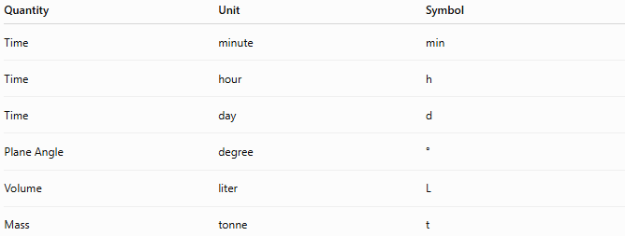
Quantity | Unit | Symbol
Time | minute | min
Time | hour | h
Time | day | d
Plane Angle | degree | °
Volume | liter | L
Mass | tonne | t

4. Other Non-SI Units
# Source: AI Source: Provided by: [Data Path: Persons Table -> ID Column: 1, Name_En Column: Motasem Essam] -> From: [ChatGPT] on [7/17/2026]
These are commonly used in specific countries or industries but are not part of the SI.
Examples:
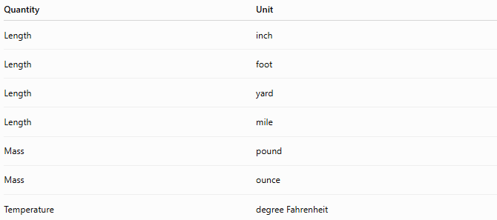
Quantity | Unit
Length | inch
Length | foot
Length | yard
Length | mile
Mass | pound
Mass | ounce
Temperature | degree Fahrenheit

SI Prefixes
# Source: AI Source: Provided by: [Data Path: Persons Table -> ID Column: 1, Name_En Column: Motasem Essam] -> From: [ChatGPT] on [7/17/2026]
Prefixes represent multiples or submultiples of a unit.
Examples:
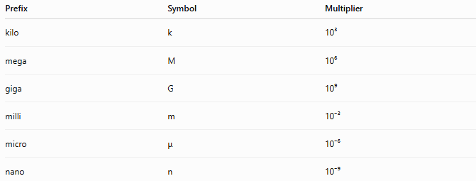
Prefix | Symbol | Multiplier
kilo | k | 10³
mega | M | 10⁶
giga | G | 10⁹
milli | m | 10⁻³
micro | μ | 10⁻⁶
nano | n | 10⁻⁹
Examples:
- 1 kilometer (km) = 1,000 meters
- 1 millimeter (mm) = 0.001 meter
- 1 microsecond (μs) = 0.000001 second

Importance of Measurement Units
# Source: AI Source: Provided by: [Data Path: Persons Table -> ID Column: 1, Name_En Column: Motasem Essam] -> From: [ChatGPT] on [7/17/2026]
Measurement units:
- Provide a universal standard.
- Ensure measurement consistency.
- Support scientific reproducibility.
- Enable international trade.
- Improve engineering accuracy.
- Simplify communication.

Applications
# Source: AI Source: Provided by: [Data Path: Persons Table -> ID Column: 1, Name_En Column: Motasem Essam] -> From: [ChatGPT] on [7/17/2026]
Measurement units are used in:
- Science
- Engineering
- Manufacturing
- Medicine
- Construction
- Surveying
- Education
- Commerce
- Transportation
- Everyday life

Examples
# Source: AI Source: Provided by: [Data Path: Persons Table -> ID Column: 1, Name_En Column: Motasem Essam] -> From: [ChatGPT] on [7/17/2026]
Length
- 2.5 m
- 15 cm
- 8 km

Mass
- 70 kg
- 250 g
- 3 mg

Time
- 10 s
- 5 min
- 2 h

Temperature
- 300 K
- 25 °C
- 77 °F

Area
- 45 m²

Volume
- 0.75 m³
- 2 L

Measurement Units vs. Physical Quantities
# Source: AI Source: Provided by: [Data Path: Persons Table -> ID Column: 1, Name_En Column: Motasem Essam] -> From: [ChatGPT] on [7/17/2026]
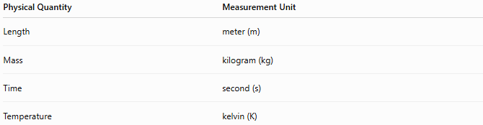
Physical Quantity | Measurement Unit
Length | meter (m)
Mass | kilogram (kg)
Time | second (s)
Temperature | kelvin (K)
A physical quantity is what is being measured, while a unit is the standard used to express it.

Common Mistakes
# Source: AI Source: Provided by: [Data Path: Persons Table -> ID Column: 1, Name_En Column: Motasem Essam] -> From: [ChatGPT] on [7/17/2026]
- Confusing physical quantities with their units.
- Mixing SI and non-SI units without proper conversion.
- Omitting units when reporting measurements.
- Using incorrect unit symbols (for example, writing "M" instead of "m" for meter).
- Confusing prefixes (such as milli (m) and mega (M)).

Key Points
# Source: AI Source: Provided by: [Data Path: Persons Table -> ID Column: 1, Name_En Column: Motasem Essam] -> From: [ChatGPT] on [7/17/2026]
- A unit is a standardized quantity used to express measurements.
- The International System of Units (SI) is the global standard.
- Measurement units are divided into:
  - SI Base Units
  - SI Derived Units
  - Accepted Non-SI Units
  - Other Non-SI Units
- SI prefixes represent multiples and submultiples of units.
- Standardized units ensure accuracy, consistency, and universal communication.

Conclusion
# Source: AI Source: Provided by: [Data Path: Persons Table -> ID Column: 1, Name_En Column: Motasem Essam] -> From: [ChatGPT] on [7/17/2026]
Measurement Units are standardized reference quantities used to express the magnitude of physical quantities. They form the foundation of science, engineering, manufacturing, and everyday life by ensuring that measurements are consistent, accurate, and universally understood. The International System of Units (SI) provides the world's most widely accepted framework of base units, derived units, and prefixes, allowing measurements to be communicated and compared reliably across countries, industries, and scientific disciplines.

